# Referenced Subflow

A workflow can be consumed as referenced subflow from a parent workflow (i.e. you want to reference a workflow that is executed inside another (main) workflow), please refer to below screenshot

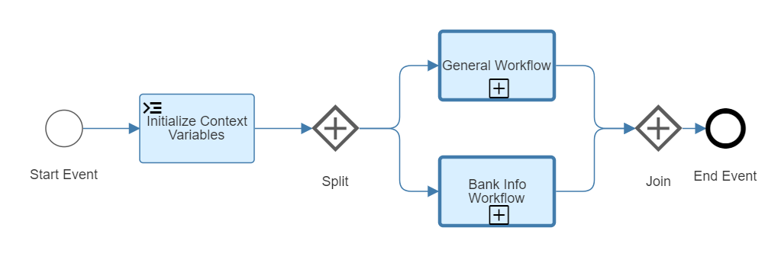

The subflow (General Workflow and Bank Info Workflow) is an external workflow, that can be reused and is deployed independently from the main workflow.

Main Workflow stores data in the workflow context, we can pass a small chunk of data to the subflow by configuring data mapping, subflow can modify this data while processing and return data back to main workflow using data mapping. Data is copied into subflow when it is started and copied back into main workflow when subflow ends.

Main Workflow calls the subflow and waits until the subflow ends, before it continues with the next item.

Subflow can be a workflow from the same project as the main workflow, or it can be any workflow deployed on the server.

We can use Principal propagation to forward information from main workflow to subflow, this information is propagated through the workflow, before we can use principal propagation, the following one-time DESTINATION needs to be configured.

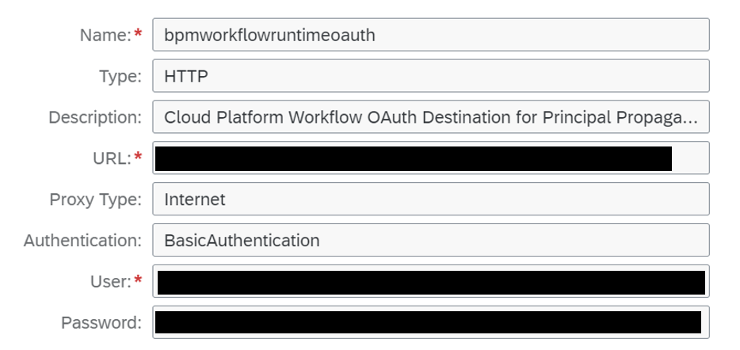

|  |  |
| --- | --- |
| **Field** | **Value** |
| Name | bpmworkflowruntimeoauth |
| Type | HTTP |
| Description | Cloud Platform Workflow OAuth Destination for Principal Propagation |
| URL | Set the destination URL to the authorization endpoint URL found in the service key that was created for the workflow service. This corresponds to the URL in the uaa.url parameter |
| Proxy | Internet |
| Authentication | Basic Authentication |
| User | Set the user to the client ID. See the uaa.clientid parameter described in the service key that was created for the workflow service |
| Password | Set the password to the secret. See the uaa.clientsecret parameter described in the service key that was created for the workflow service |

Every service binding and service key can have their own client secret. If the binding or service key is deleted, the client secret can become invalid. Therefore, you use the client secret from a dedicated service key that you don’t plan to delete.

# Workflow as a Referenced Subflow

In Referenced Subflow properties, choose DETAILS Tab, we need to provide WORKFLOW DEFINITION ID (i.e. workflow you want to use as subflow, in this case General and Bank Info Workflow) and enable PRINCIPAL PROPAGATION, will use the credentials of a user while invoking the referenced subflow

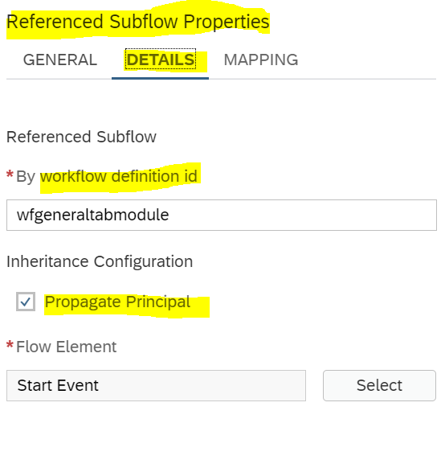

# Workflow Context Mapping

In Referenced Subflow properties, choose MAPPING Tab, mapping is used to transfer data between the main workflow and subflow. There are two transfer directions

* Input Mapping: Data passed on to the Subflow, i.e. Workflow Context of parent workflow is mapped to the child workflow, this will be used as Start Payload for the Child Workflow. The Source Context Path contains the Context of the Main Workflow, it is mapped to the Target Context Path that contains the context of the Subflow
* Output Mapping: Data that is transferred back from Subflow to the Main Workflow, when the execution of Subflow ends. In this case Source Context Path contains the context of Subflow and Target Context Path contains the context of the Main Workflow

